Nursing care of patients with substance use disorders:
- BG
  - aversion therapy (90% sober for at least a year)
    - Drugs to induce n/v, constrict esophagus
  - CAC III (MH setting)
- Matter of willpower?
  - AMA listed as legitimate disease
- New DSM5: “Substance Use Disorder”
  - Cluster of cognitive/behavioral/ psychological symptoms indicating that the individual continues use despite significant substance related problems
  - Still will hear “abuse” “dependence”; more negative connotations
  - “[substance] use disorder”
    - Marijuana referred to as “cannabis”
  - Criterion: (paraphrased, reference DSM for real wording)
    - Criterion 1-4: Impaired control
      - Substance taken in larger amounts/longer period of time then intended
      - Persistent desire/inability to cut down/control substance use
      - Great time spent in obtaining substance
    - Criterion 5-7: Social impairment
      - Fail to keep social engagements
      - Absence from work
    - Criterion 8-9: Risky use
      - Use in spite of pressing medical advice
      - Situations where dangerous (ETOH and driving)
    - Criterion 10-11: Pharmacological
      - Tolerance: Needs more to get desired effects
      - Withdrawal (or abstinence syndrome): physiological symptoms when taken away
      - Sx of tolerance/withdrawal during appropriate medical tx with prescribed meds should NOT be counted when diagnosing SUD
  - Addiction v dependence
    - Addicted: psychological. Do anything to get substance, interferes with life
    - Dependence: not the intense cravings. If substance taken away, will go through withdrawal.
    - “Drug seeking” pts: typically just trying to avoid withdrawal
      - Prescribed drug use for pain: not going to buy heroin off the streets, but trying to control pain; difficult to treat. Over time, will need greater amount for same relief. LIFETIME STRUGGLE. Pts who accidently OD (not suicide attempt)
  - Healthcare mgmt.
    - Pain clinics
    - Moral quandary: dependence is hard to manage pain
      - Same with benos, sleeping pills.
  - Severity rating:
    - Mild (2-3 symptoms)
      - SBIRT (MI)
    - Moderate (4-5 symptoms)
      - SBIRT (MI)
    - Severe (6+)
  - Specifiers
    - In early remission (3-12 months)
    - In sustained remission (12+ months)
    - In a controlled environment
      - No access to substance, for example jail
    - On Maintenance therapy
- ETOH
  - Slide 2: Fact/figures
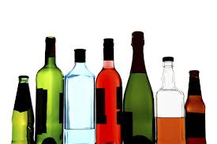
    - NIH recommended site
    - ETOH most widely abused; withdraw/ abstinence syndrome life threatening
    - Biggest misnomer: will never quit unless get tx (certain percentage of ppl able to quit)
    - ETOH HUGE attributing factor to ED Admissions; 72 associated medical conditions
      - Thyroid, bp, mh, acute psychosis, renal/hepatic
    - Earlier someone starts drinking, more likely to become addicted
  - Legal limits in Colorado; DRIVING IS A PRIVELEGE NOT A RIGHT
    - Driving Under Influence (DUI): BAC 0.08 (80 mg/dL)
    - Driving While Ability Impaired (DWAI): BAC: 0.05 or higher (50 mg/dL)
      - First time may not lose license or for shorter period of time
    - Underage Drunk Driving (UDD): any alcohol content underage (“Justin Bieber”)
    - Refusal of breathalyzer/BAC: loose license for 1 year. “Implied consent law”
      - When given license, consent to field sobriety test
      - “Reasonable suspicion” but sometimes DUI check points
      - Refusal is admission of guilt
    - DUID: Driving under influence of drugs
  - Pharmacotherapy for ETOH Use Disorder
    - Antabuse (Disulfiram)
      - When first prescribed, given drug and made person drink to experience reaction
        - Flushing, tachycardia, sob, n/v, throbbing HA
      - SE: drowsiness (usually dissipates in weeks), ha, metallic/garlic taste, CAN BE HEPATOTOXIC (monitor liver function tests; usually happens within first 3-6 month)
      - Pt education:
        - Long halflife. Can stay in system up to 2 weeks
        - Caution hidden forms of ETOH: mouthwash, lotions, creams, uncooked foods containing alcohol (i.e. vanilla extract is 35% alcohol)
        - Most effective in liquid form; monitored
      - Negative reinforcement: thought of negative consequence prevents someone from drinking
      - Blocks the enzyme for oxidation of metabolite called acid aldehyde; buildup causes symptoms of ETOH/Antabuse rxn
      - Outcome studies: doesn’t show long term outcomes
        - Preferable if done right/monitored
        - Courts love it
      - Clinic for compliance
    - Naltrexone (like naloxone “Narcan”)
      - Approved 90s
      - Opiate antagonist
      - Mixed reviews
        - Pt can still drink, no SE however will not get “buzz” or high (because receptor blocked)
        - Reasoning: if not getting pleasurable effects, people will not drink as much
        - Still get bad systemic effects of ETOH use
    - Acamprosate (Campral)
      - Sobriety maintenance
      - Cannot start until person has been off ETOH/detoxed 3-5 days
      - Believed to decrease craving for ETOH
      - MOA: agonizing GABA (inhibitory neurotransmitter)
      - Mixed outcome studies
    - Vivitrol (injectable form of Naltrexone)
      - Extended release given q month
    - Topamax
      - Not FDA Approved. Often used “off label” to decrease craving
      - FDA approved: migraines, bipolar disorder, seizures
  - Withdrawal
    - Kindling effect
    - s/sx: termors, nv, diaphoresis (profuse), weakness, tachy/hypertensive; anxious, hallucinations, seizures, delirium tremens (DTs)
      - DTs (“shaking frenzy”) can be fatal: may require IV, ICU admits
        - With treatment: 15% fatal; without tx: 35%
      - Grand mal seizures; Dilantin will not help (especially if HISTORY of szs with withdrawal; again Kindling)
    - Have pt describe their history
    - Tx/Nursing Intervention:
      - Safety (fall prevention)
      - Monitor vital signs
      - Push fluids-juices/Gatorade/water
      - Administer CIWA
      - Pharmacological intervention, ie, short acting benzos
      - Vitamins: Thiamine (B1) to prevent Wernicke Korsakoff Syndrome (encephalopathy) which can be permanent. Referred to as “wet brain”
    - Tx:
      - Pharmacological/comorbidities (utilized only 9% of the time)
      - 12 step programs
      - Inpatient/Outpatient
      - Family therapy
      - Intervention
      - Relapse prevention (focus on confronting denial): cognitive-behavioral, motivational interviewing, solution focused, psycho-educational
  - ETOH and old age
    - Increase in number of alcoholic patients due to sheer increase of number of pts
    - Need to assess/address
    - Also, polypharmacy (Interactions)
    - Assessment
      - Michigan Alcoholism Screening Test, Geriatric Edition (MAST-G)
      - CAGE Questionnaire 2 or more “yes”=problem drinking
        - Cut Down?
        - Annoyed?
        - Guilty?
        - Eye opener?
      - Alcohol screening inventory; EVEN JUST ASKING (SBIRT)
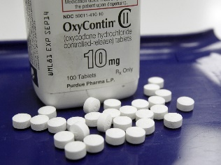
- Opioid:
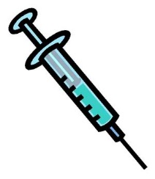
  - Types:
    - Heorin: smoked/IV/smoked/snorted
      - IV route more dangerous
    - Morphine
    - Oxycodone (prescription pain meds)
      - Addiction/dependency happens quickly
      - Withdrawal severe, but not usually life threatening
        - Can begin within hours of last dose, but cravings last for years
  - Pharmacologic tx: PLAN WITH ALL IS TO TAPER OFF, difficult (success rates?)
    - Methadone (short term or long term): HIGHLY ADDICTIVE
      - HARM REDUCTION
      - Requires high doses to get “high”
    - Buprenorpihne: “weaker” analgesic (SL, transdermal)
    - Suboxone: combo of buprenorphine and naloxone
    - Ideal is to dose for maintenance without getting high
      - UAs to test for (+) methadone; (-) heroine
  - Non pharmacologic tx:
    - Relapse prevention programs
    - NA 12 step programs
    - Contingency mgmt. (vouchers/point systmes)
    - Needle exchange programs
    - Bleach “works”
  - Case study: 34 yo female, baby born 38 wks, born SGA. Labile pain, diaphoretic, withdrawn re: baby
    - Clues: low birth weight/lethargic baby, High BP/HR/Resp, body aches/high pain/ slow labor
    - Narcotic/opioid withdrawal
    - Nursing dx: ineffective denial
      - Outcome: pt will verbalize association of drug use to current situation
      - Interventions:
        - Review definition of drug dependence and categories of symptoms (patterns of use/impairment of use/tolerance)
        - Confront and examine denial and rationalization in peer group; use confrontation with a a caring attitude
          - Denial major defense mechanism
        - Ascertain reason for beginning abstinence and involvement in therapy
      - Priorities:
        - Pt to provide information about condition/prognosis/tx needs
        - Strengthen individual coping skills
        - Promote family/friend involvement in rehab group
- Stimulants
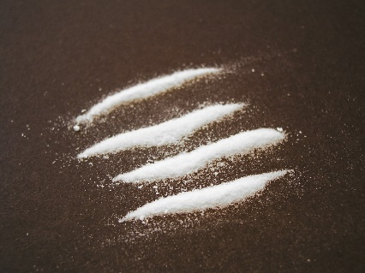
  - Cocaine
    - Powerfully addictive: euphoric/energetic
    - Smoked (crack), injected, snorted (SL? Google case study)
    - Medical risk:
      - Incr risk of cardiac event; temp/bp/hr
    - Young person w/ s/sx of heart attack: DRUG SCREEN
    - Tx:
      - No FDA approved pharmacologic txs
      - Vaccination showing promise
      - Non pharmacologic: same as other addictions
  - Crystal meth (methamphetamine)
    - Meth started in 1980s Hawaii and moved to west coast; super labs/home labs
    - Snorted/smoked injected
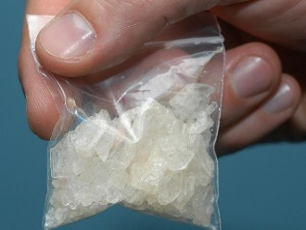
    - Increases release of DA and blocks reuptake
      - Intense euphoria; diminishes with each use; continue using to try and gain feelings again
      - Needed to function
      - Severe structural/functional changes associated with memory and emotion
      - Chronic/relapsing
    - Physiological manifestations:
      - Extreme weight loss, “meth mouth”, anxiety/confusion/insomnia/mood disturbances/ violent behavior
      - Meth induced psychosis (difficult to distinguish from schizophrenia)
        - Meth: usually visual/tactile
        - Schizophrenia: hallucinations usually auditory
    - Tx:
      - Pharmacologic:
        - Antipsychotic meds for pscyhosis (Haldol, risperdol)
        - Modafinil: mild stimulant used but showed no effect
      - Comprehensive Cognitive behavioral tx
      - 12 step programs
      - Contingency mgmt.
- Marijuana
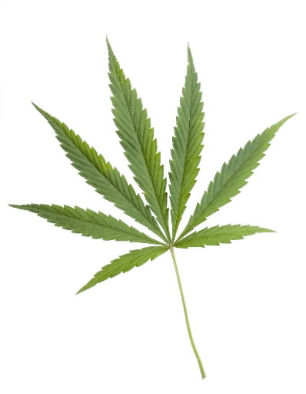
  - Cannabis/Pot/THC
  - ADOLESCENTS: attention/memory/IQ permanent effects even when quit
  - CAN lead to abuse/dependence
    - Amotivational syndrome
  - Legal:
    - 16 states legalized for medicinal use; not legal under federal law
      - Decreases n/v (following chemo), increase appetite, decrease intraocular pressure (glaucoma), analgesic effects
  - SPICE
- Tobacco/Nicotine (covered in previous lectures): MOST PREVENTABLE CAUSE OF DISEASE/DISABILITY IN THE US
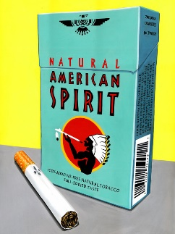
  - Tx/medications:
    - Nicotine replacement treatment (gum, patches, lozenges)
    - Bupropion (zyban, wellburin)
    - Verencicline Tartrate (Chantix)
  - SMOKING cessation education/intervention by nurses
- Gambling disorder
- Impaired professionals
  - ETOH use parallels use of public, lower for marijuana, inhalants, hallucinogens, heroin
  - Use of prescription drugs significantly HIGHER
    - Male nurses more likely
  - Abusers by specialties:
    - Oncology
    - Psychiatry
    - Emergency and adult critical care
  - Warning signs:
    - Decrease in overall work quality
    - Errors in judgment
    - Periods of confusion/lack of concentration
    - Missed deadlines
    - Excessive time completing tasks
    - Lack of memory
    - Medication errors
    - Overlooking deteriorating conditions
    - Repeated absenteeism/tardiness
    - Leaving work early
    - Unexplained disappearances
    - Increased use of pain meds recorded
    - Increase in wastage or breakage of drugs
    - Missing drugs/unaccounted doses
  - Health professionals respond well to interventions and have good tx response
    - HELP diverters, not punish
    - Speak to risk mgmt./ managers/etc if suspicion
    - Report to board with evidence
Practice problems:
  - Lippincott Chapter 4, Test 3. Questions 26-100.
  - Saunders, Ch 75, p. 1059. All questions 923-932.

